i. Display name, phone number of students with ‘a’ as the second letter in their names who read subject CS301.

select name,phoneno from STUDENT,RESULT WHERE STUDENT.NAME LIKE '_a%' AND RESULT.SUB_CODE='CS301' AND STUDENT.ROLLNO=RESULT.ROLLNO;

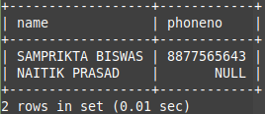

ii. Display the marks for all available subjects for the students who born in JUNE.

SELECT RESULT.ROLLNO,SUB_CODE,MARKS FROM RESULT,STUDENT WHERE MONTH(BIRTHDATE)=06 AND STUDENT.ROLLNO=RESULT.ROLLNO;

iii. Show the student details of 5th semester Computer science and engineering Department.

SELECT * FROM STUDENT WHERE SEMESTER='SEM5' AND DEPTCODE='CSE';

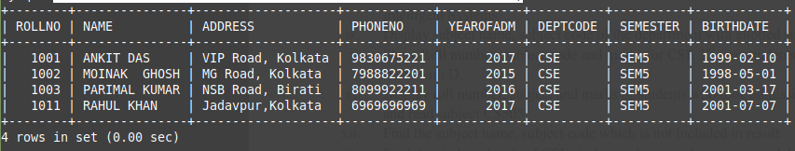
iv. Show the subject details of 3rd semester Computer science and engineering Department.

SELECT * FROM SUBJECT WHERE SUBJECTCODE LIKE 'CS3%';

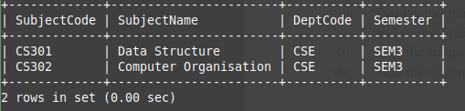
v. Display the department name for which some student get more than 90.

SELECT NAME,DEPTNAME FROM STUDENT,RESULT,DEPARTMENT WHERE MARKS>90 AND STUDENT.ROLLNO=RESULT.ROLLNO AND STUDENT.DEPTCODE=DEPARTMENT.DEPTCODE;

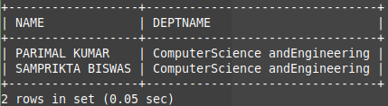

vi. Display the student name who reads in 5th semester and get more than 80 in any subject

SELECT DISTINCT(NAME) FROM RESULT,STUDENT WHERE SUB_CODE LIKE '%5%' AND MARKS>80 AND STUDENT.ROLLNO=RESULT.ROLLNO;

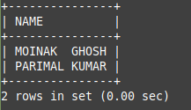

vii. Display the name of CSE student who born in 2000 and get more than 80 in CS301

SELECT NAME FROM RESULT,STUDENT WHERE STUDENT.DEPTCODE='CSE' AND MARKS>80 AND SUB_CODE='CS301' AND YEAR(BIRTHDATE)=2000 AND STUDENT.ROLLNO=RESULT.ROLLNO;

viii. Display the department details with less than 80 students which has subject name Intelligent Systems.

SELECT DEPARTMENT.* FROM SUBJECT,DEPARTMENT WHERE STUDENT_ALLOTTED>80 AND SUBJECT.SUBJECTNAME='Intelligent Systems' AND DEPARTMENT.DEPTCODE=SUBJECT.DEPTCODE;

ix. Display subject name, subject code of the department with allotted student less than 100.

SELECT SUBJECTCODE,SUBJECTNAME FROM SUBJECT,DEPARTMENT WHERE STUDENT_ALLOTTED<100 AND SUBJECT.DEPTCODE=DEPARTMENT.DEPTCODE;

x. Show Roll number, subject code and marks for CSE 3rd year students where subject name starts with D.

SELECT ROLLNO, SUB_CODE,mARKS FROM RESULT,SUBJECT WHERE SEMESTER='SEM5' AND SUBJECTNAME LIKE 'D%' AND SUBJECT.SUBJECTCODE=RESULT.SUB_CODE;

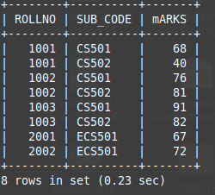

xi. Display roll number, subject and marks of students who took admission in the year 2017 and read subject CS505.

SELECT RESULT.ROLLNO, SUB_CODE,mARKS FROM RESULT,STUDENT WHERE SUB_CODE='CS505' AND YEAROFADM=2017 AND RESULT.ROLLNO=STUDENT.ROLLNO;

xii. Find the subject name, subject code which is not included in result.

SELECT SUBJECTCODE,SUBJECTNAME FROM SUBJECT WHERE SUBJECT.SUBJECTCODE NOT IN (SELECT SUB_CODE FROM RESULT);

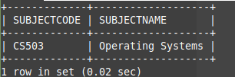

xiii. Find the student details of CSE students whose marks are not available in result.

SELECT * FROM STUDENT WHERE ROLLNO NOT IN (SELECT ROLLNO FROM RESULT) AND DEPTCODE='CSE';

